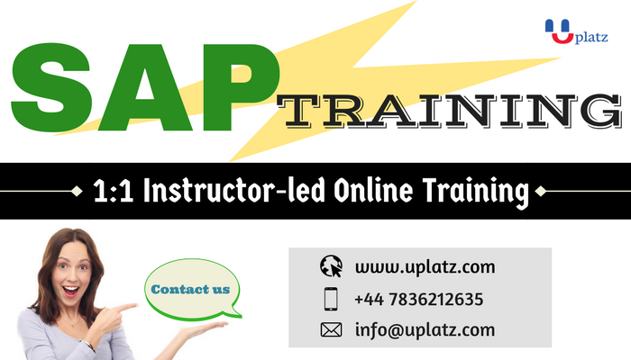

COURSE DETAILS & CURRICULUM
The Specification is the link between the business requirements (another document produced by the client) and the technical design (a separate document). It covers the following:
- Reference to the business requirements (customer requirements) given in the solution proposal.
- Write mapping rules into standard SAP products.
- Describe the solution from an external (user or customer) point of view.
With career dragons, while writing the functional specifications you will be trained to
- Learn all the components within the standard Functional specification
- Learn to know SAP behind the screens
- Speak to ABAP consultants and explain them the change in design expected
- Prepare test scripts and learn to write test scenarios for ABAP consultants and business users
- Learn to prepare workflow and swim lane diagrams
- Work with tables, data dictionary, routines, formulas that are required while writing the Functional Spec.
Customers shall be enabled to recognize that all their requirements are taken into consideration. For approval of the Specification they have to understand the solution. A good functional specification document contains enough detailed information about the business process and equally understandable by the technical developer such as ABAP consultant to complete an accurate technical design document and eventually write the code. The functional specification document should not only highlight the presence of a gap, but should demonstrate how the business process, accompanied by automation, will close the gap. Since most of the developments in an SAP Implementation Project are done by developers based offshore mainly in India and we will teach the coordination with the ABAPer while you will see your written specification will be developed into SAP. You will learn how face-to-face quick resolution scenario typically cannot happen if you have an off-shore technical contingent in play.

