SAP MDG Online Training
You need to spend 40-45 hours to learn SAP MDG from our Trainer.
What can you expect from us by End-of-the-Course?
- Real-Time Oriented Training
- Study Materials
- Assignments and Real-Time scenarios
- Mock Interviews and Resume preparation
Target Audience (If Technical) are with the below skills:
- Basic understanding of SAP
- Core ABAP (RICEFW Objects) and OOABAP
- Enhancement Framework
- IDOCs (Good to have)
- Basic understanding of Webdynpro ABAP or FPM (Good to have)
If you don’t have above skills, don’t worry. We can provide you the Live Session Recordings to gain the required knowledge and will assist.

Unit 1: Getting started with SAP Master Data Governance (MDG)
- SAP MDG Overview
  - Introduction to MDG
  - SAP MDG Capabilities and Use Cases
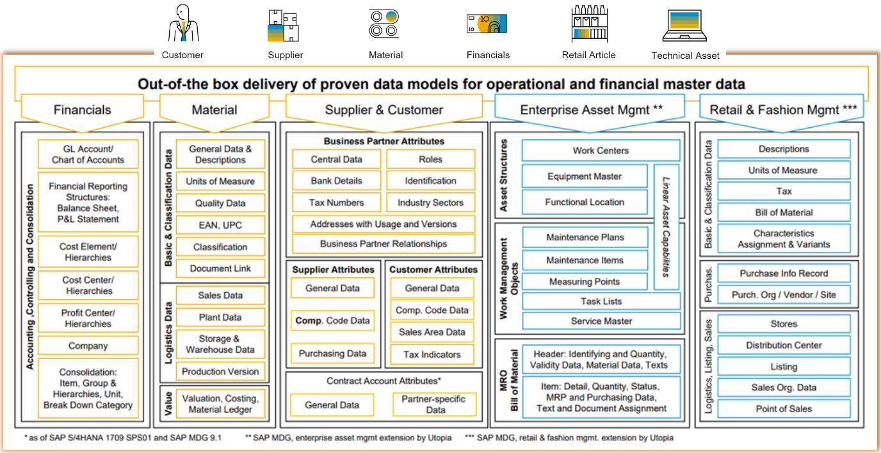
  - User Interfaces of MDG
- MDG Architecture
- Deployment options
  - Hub Option
  - Co-Deployment Option
- MDG Storage Areas
- Flex Vs Re-use
- A Typical Governance process flow in MDG
- Business Processes in MDG
- Understanding of Out-of-the-box domains
  - Finance
  - Supplier
  - Material
  - Customer
  - Business Partner
  - Enterprise Asset Management (EAM)

Unit 2: Baseline Configurations
- Version Identification
  - MDG on ECC
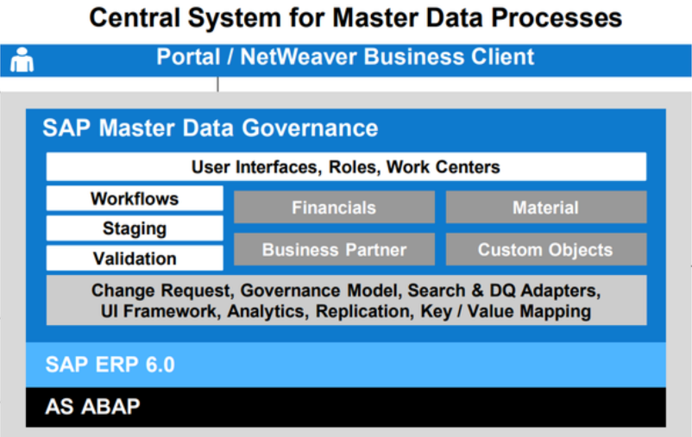
  - MDG on S/4 HANA
- Installed Components
- Business Functions Activation for various domains
- Business Configuration Set (BC Set) Activation
  - Understanding BC Sets
  - BC Sets Activation
  - Validate the BC Set Status
  - BC Set Activation Logs
- Pre-Requisites to use MDG Workflows
  - Activate Event Type Linkage
  - Configure Workflow Tasks
  - Validate SWU3 Configuration
- Activate Data Model and Adjust Staging
- System Validation
- Validating various business processes
- Understanding MDG Authorizations and Roles
- Assigning User Specific Roles in MDG

Unit 3: Data Modeling
- Introduction
- Data Model Configuration Activities
  - Define Business Object Type Codes
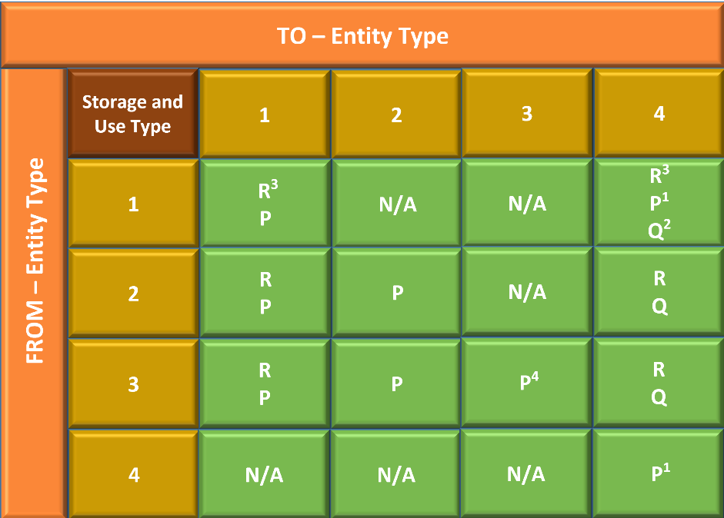
  - Define Prefixes for Internal Key Assignment
  - Edit Data Model
  - Define Authorization Relevance per Entity Type
  - Generate Data Model Specific Structures
- Entity Types and Attributes
  - SU Type 1 Entity
  - SU Type 2 Entity
  - SU Type 3 Entity
  - SU Type 4 Entity
- Entity Relationship Types
  - Leading Relationship
  - Qualifying Relationship
  - Referencing Relationship
  - Foreign Key Relationship
- Reuse Active Area
- Extend Data Model by New Entity Types / New Attributes to Existing Entity Types

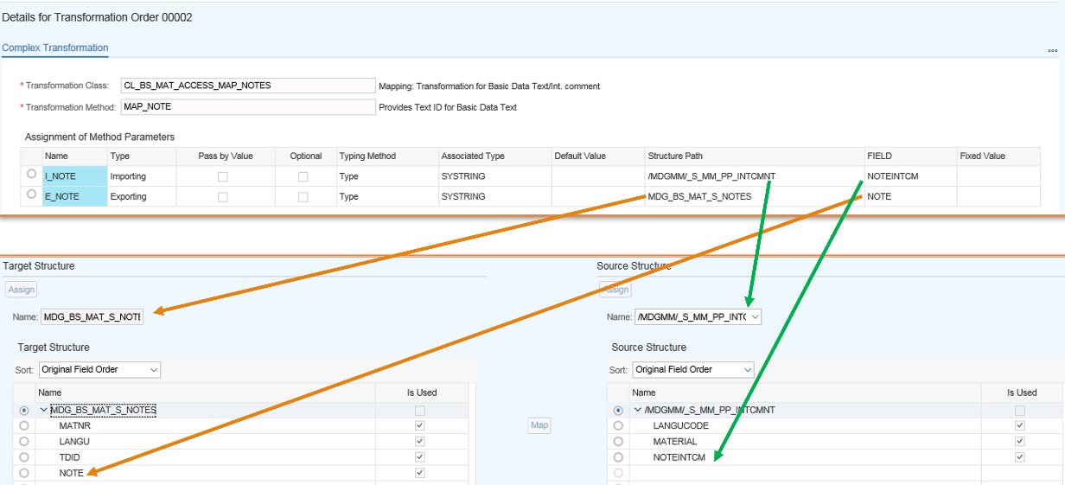
Unit 4: Service Mapping Tools (SMT)
- Introduction
- Mapping step with Multiple Source Structures
- Field mapping (Simple Transformation)
  - Conversion Classes
- Complex Transformation
  - Transformation Methods
  - Fields Checks
  - Condition Methods
- Calling SMT in ABAP programs
- Extend SMT Mappings

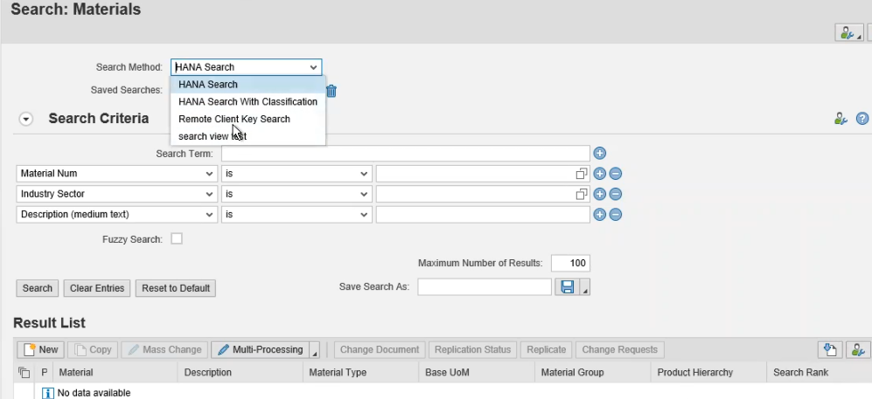
Unit 5: Data Quality and Check
- Types of Search Applications
- Duplicate check configuration
- Match profile configuration
- Define Search Views
- Validations and Derivations using “USMD_RULE_SERVICE” BAdI
  - Same-Entity and Cross-Entity Validation
  - Same-Entity Derivation
- Cross entity derivation using “USMD_RULE_SERVICE_CROSS_ET” BAdI

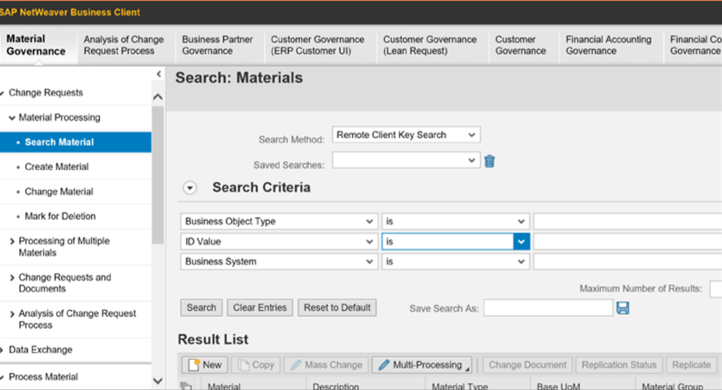
Unit 6: User Interface (UI) Modeling
- Introduction
- Floor plan Manger (FPM) Basics
  - Introduction to FPM
  - Getting started with FLUID
  - Create Simple FPM Application
  - Various Floor Plans
  - Understanding Feeder Class
- Understanding MDG UI Framework
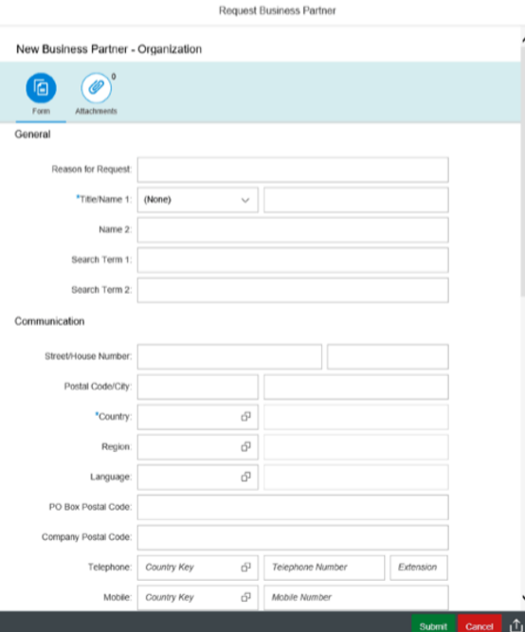
- UI Configuration Activities
  - Manage UI Configuration
  - Define Field Properties
  - Define available UI Applications
  - Define and Assign Print forms for SOP
  - BADIs for UI modelling
- Extend the UI as per user defined criteria
  - Customizing
  - Enhancement
  - CBA (Context Based Adaptation)
  - Deep-Copy
  - How to choose the right technique?

Unit 7: Process Modeling
- Introduction
- Define Governance Scope
- Business Activity
- Change Request Type configurations
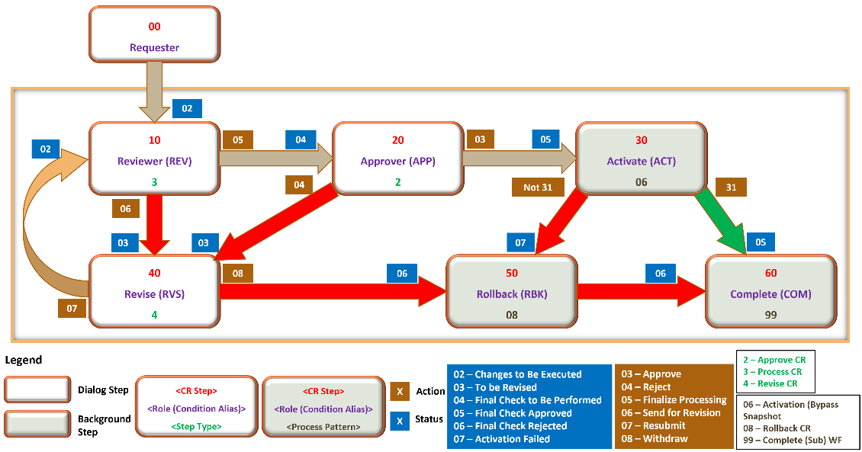
  - Create new Change Request type
  - Edit Statuses of Change Request
  - Configure properties of Change Request Step
  - Define Step Types of Actions
- Rule based workflow (RBWF)
  - Introduction
  - Decision Tables
    - Single Value Decision Table
    - User Agent Decision Table
    - Non-User Agent Decision Table
  - Configure RBWF for custom / standard CR Type
- Other MDG Workflows
- BAdI’s for Customizing RBWF
  - Parallel result Handler BAdI
  - Dynamic Agent Selection BAdI
  - Context BAdI
  - System Caller BAdI

Unit 8: Data Replication Framework (DRF)
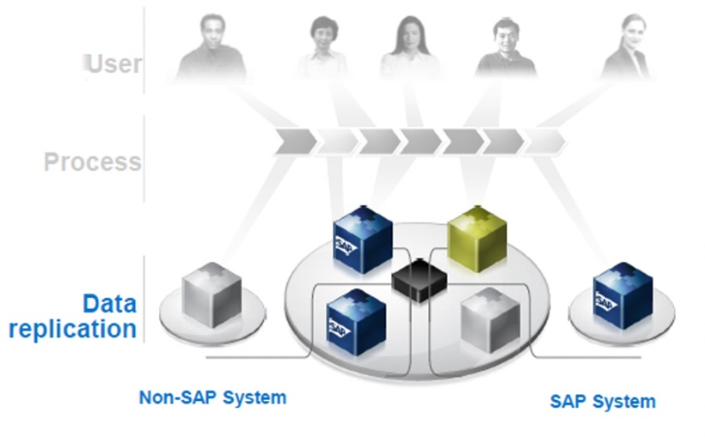
- Introduction
- Different ways to Replicate the Master Data
- Outbound Implementation
- Understanding Outbound Implementation Class
- Filter Criteria
- Replication Model Configuration
- Replication Modes
- Manual & Automatic replication
- Replication Logs
- Configure Replication using SOA service (Optional)
- Key Mapping, Value Mapping

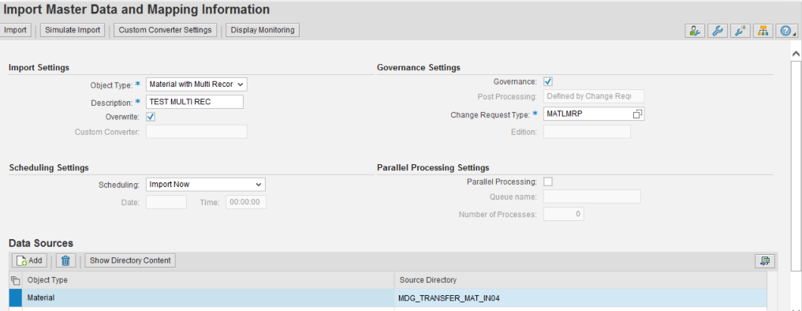
Unit 9: Data Import Framework (DIF)
- Introduction
- Configuring File Paths (Source / Archive Paths )
- Linking File paths to BO types
- Import using XML & CSV files
- Data Import Monitoring
- BAdI for File conversions

Unit 10: Enriching MDG Standard Code/Features to User Requirement
- Introduction
- Custom Data Model Creation (Flex and Reuse Models)
- Custom FPM UI application
- Custom Search Application
- SOP UI Application
- Creating User roles for various business Processes

