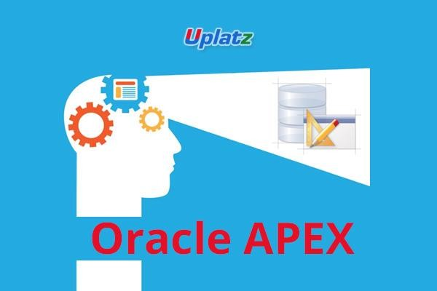
ADMINISTRATION

Oracle APEX Administration – Course Syllabus

- Overview of Oracle Application Express (APEX) Administration
- Installation of Windows 10 on Oracle Virtual Box
- Installation of Oracle 19c Database and Create Database
- Installation of Oracle APEX 20.1
- Installation of Tomcat
- Installation of ORDS
- Oracle APEX Admin Tasks

