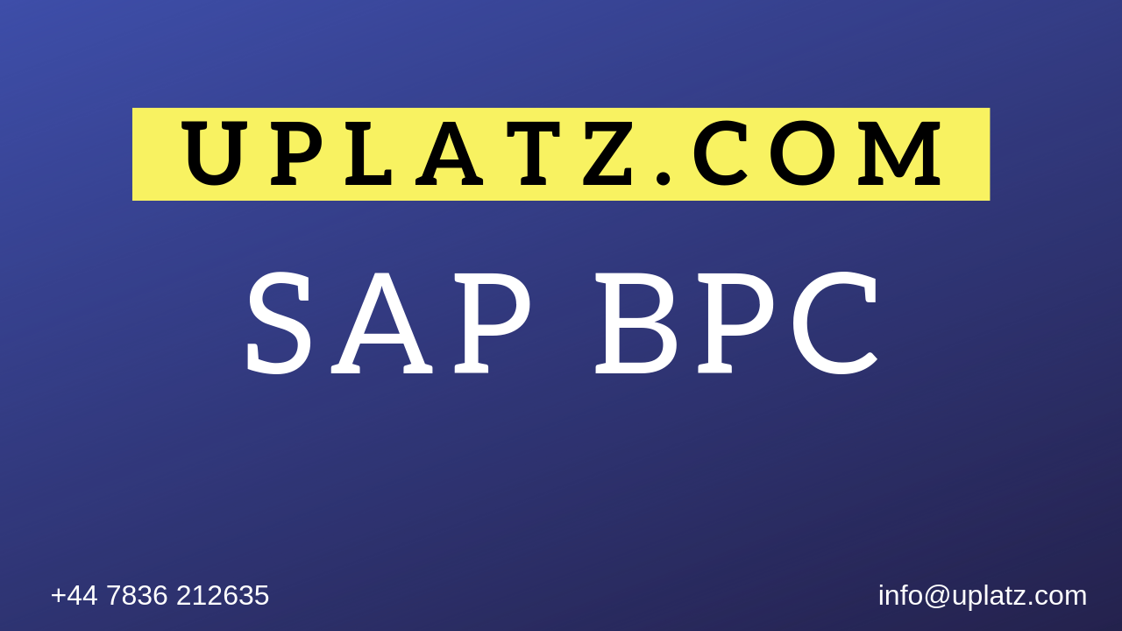
SAP BPC (basic to adv) – Course Syllabus

- Script Logic and Calculations
- Business Rules
- EPM add-in
- Integrated Planning
- BW Integration
- Models
- Environments and Dimensions
- Administration
- Data Manager
- Analysis for Office
- BPC Web client consolidation
- Process Control
- Architecture

