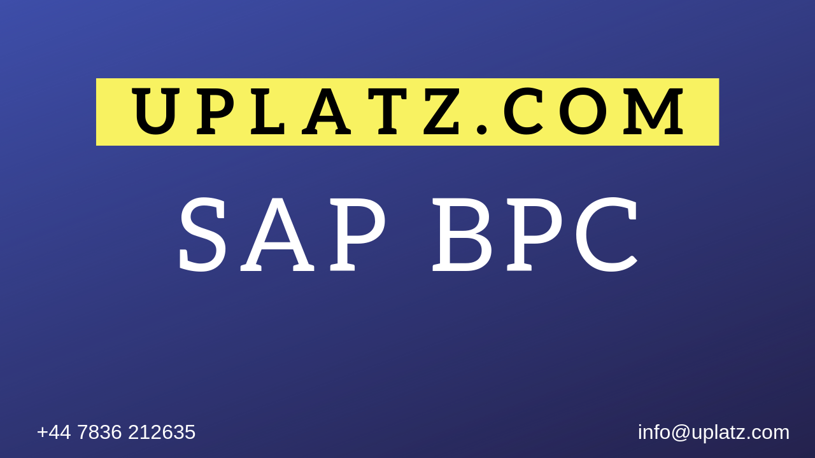
SAP BPC (comprehensive) – Course Syllabus

Unit 1: Introduction of BPC

Unit 2: SETUP – Environment, Model & Dimension Management

Unit 3: Data Manager Packages (DM Packages)

Unit 4: Reporting

Unit 5: Security

Unit 6: Loading Transaction Data from Source Systems

Unit 7: Script Logic

Unit 8: BPC for Web

Unit 9: Audit Reports

Unit 10: Projects

Unit 11: Consolidation

Unit 12: Planning

